**PROJECT : ARITHMETIC CALCULATOR USING JAVA**

**DEVELOPER : B.MAHENDRA**

**PROJECT DESCRIPTION :**

In this program I used a class and a method to develop a simple claculator. The class name is CalculatorUsingJava and I used a method Calculator to perform operations. In that I used switch case to select options. I called this function from main method.

**FLOW CHART**

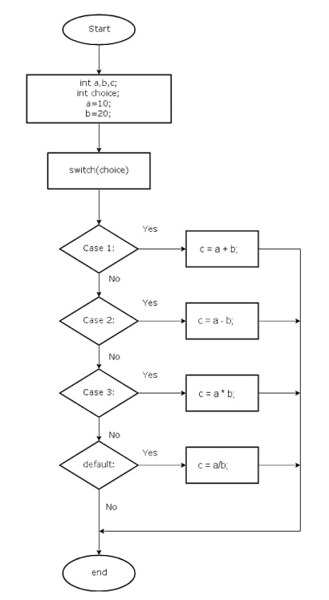

**CONCLUSION :**

It worked for all the numbers. It gave output for all four operations.